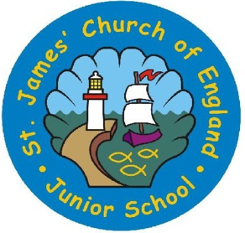
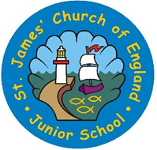
Year 3 and 4 Curriculum Plan – French
With exploring minds and faith; we grow and learn together

The intention of our curriculum at St James’ C of E Junior School is to:
Learning is memorable at St James; a relentless focus on the learner helps our skilled staff plan diverse and rich activities that engage children in a way that makes learning stick. Our unique approach of ‘Learning to learn’ gives children life-long study skills. Children here soon become independent ‘finder outers’. Driven by a passion for study children develop self-confidence and independence. Traditional “chalk & talk” strategies don’t fit with us here at St James’. Instead, teachers facilitate the learning with big questions and frequent opportunities for discussion and exploration, whether that be individually or collectively in groups.
In short, teachers seeing the lesson through the eyes of the learner allows for high quality teaching and learning across the school.

 | French
 | Autumn |  | Spring |  | Summer
Cycle 1  2018/19 | Locations and Greetings | Counting to 10 and the Classroom | Further greetings and counting to 20 | Days of the week, weather and alphabet | Further Counting  My Family  Colours | Pets  Further Counting to 40
Cycle 2  2019/20 | Countries surrounding France  Revision | Telling the time  Revision | Daily Routines  revision | Months of the year  Birthdays  Weather revision | Using adjectives including colours | Petshop  Revision

Languages National Curriculum Expectations LKS2 | Cycle 1 18/19 |  |  | Cycle 2 19/20
 | Autumn | Spring | Summer | Autumn | Spring | Summer
listen attentively to spoken language and show understanding by joining in and responding
explore the patterns and sounds of language through songs and rhymes and link the spelling, sound and meaning of words
engage in conversations; ask and answer questions; express opinions and respond to those of others; seek clarification and help*
speak in sentences, using familiar vocabulary, phrases and basic language structures
develop accurate pronunciation and intonation so that others understand when they are
reading aloud or using familiar words and phrases*
present ideas and information orally to a range of audiences*
read carefully and show understanding of words, phrases and simple writing
appreciate stories, songs, poems and rhymes in the language
broaden their vocabulary and develop their ability to understand new words that are introduced into familiar written material, including through using a dictionary
write phrases from memory, and adapt these to create new sentences, to express ideas clearly
describe people, places, things and actions orally* and in writing
understand basic grammar appropriate to the language being studied, including (where relevant): feminine, masculine and neuter forms and the conjugation of high-frequency verbs; key features and patterns of the language; how to apply these, for instance, to build sentences; and how these differ from or are similar to English.
The starred (*) content above will not be applicable to ancient languages.

