Teaching for Mastery at St James’ CE Junior School Non-negotiables

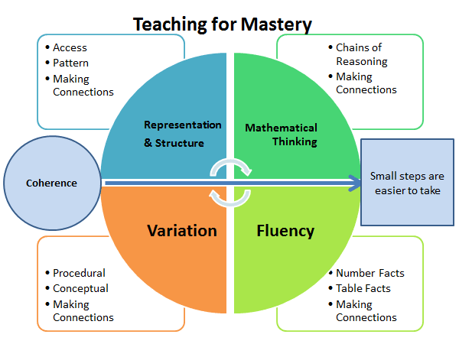

Features of a lesson
∙ Teaching the whole class together (exception of SEN children working substantially BE)
∙ Precise use of mathematical language
∙ Speaking in full sentences
∙ Small steps
∙ Procedural variation -How is variation in the examples used to draw attention to certain features and to provide opportunities for intelligent practice?
∙ Conceptual variation -How is the concept presented in different ways?
∙ Opportunities for children to go deeper
∙ Analysis of strategies
∙ Discussion including sharing and critiquing of answers and strategies
∙ Misconceptions addressed and planned for
∙ Concrete resources used in most lessons
∙ Problem solving embedded into the curriculum (not extra)
∙ Weekly arithmetic tests and Skills Checks
∙ Working wall displays

